2022-2023 SUPPLY LISTS
Toddlers
PLEASE LABEL:
Washable Crayola Crayons (JUMBO size)- 8 Pk
Washable Crayola Markers (Classic Colors)- 8 Pk
Washable Crayola Watercolors (Strip of 8)
Glue Sticks- 4
Fiskars Scissors (Crawlers and Climbers ONLY)
Playdoh-Variety 4 Pack
Washable Tempra Paint
Blue, Red, Yellow, Green, Orange, Purple, Pink, Brown, Black, White
Paint Smock/Old Adult T-shirt
9 ½ x 15” Bib
PLASTIC Folder w/2 pockets (for daily papers)
Kidnapper for naptime
(attachable pillow and blanket)
Small Lunch Box/Bag (for daily snack time)
Non-Spill Juice Cup (for daily snack time)

PLEASE DON’T LABEL:
Ziploc Bags (Sandwich, Quart, or Gallon)
Baby Wipes-Unscented-(2)
Paper Towels (2)
Kleenex (2)
Foaming Soap (3)
Clorox Wipes (2)
Off Family Care Insect Repellent (NO DEET)
Coppertone Kids Continuous Spray Sunscreen
(50 SPF)

3 Year Olds
PLEASE LABEL:
Washable Crayola Crayons (JUMBO size)- 8 Pack
2-Washable Crayola Markers (Classic Colors)- 8 Pack
2-Washable Crayola Watercolors (Strip of 8)
Colored Pencils- 12 Pk
Elmer’s Washable Glue (2)-Small Bottle
Glue Sticks- 4
Fiskars Scissors
Washable Paint Sticks
Paint Smock/Old Adult T-shirt
PLASTIC Folder w/2 pockets (for daily papers)
Non-Spill Juice Cup (for daily snack time)
Small Lunch Box/Bag (for daily snack time)
Kidnapper for naptime
(attachable pillow and blanket)
FOR FULL DAY STUDENTS ONLY
Change of Clothes in a Ziploc Bag
NO BACKPACKS-School will supply tote bag

PLEASE DON’T LABEL:
Ziploc Bags (Sandwich, Quart, or Gallon)
Playdoh-Variety 4 Pack (with cutters)
Germ-X
Expo Markers-Fine Point or Regular
Baby Wipes-Unscented-(2)
Paper Towels (2)
Kleenex (2)
Foaming Soap (2)
Clorox Wipes (2-3pk)
Off Family Care Insect Repellent (NO DEET)
Coppertone Kids Continuous Spray Sunscreen
(50 SPF)

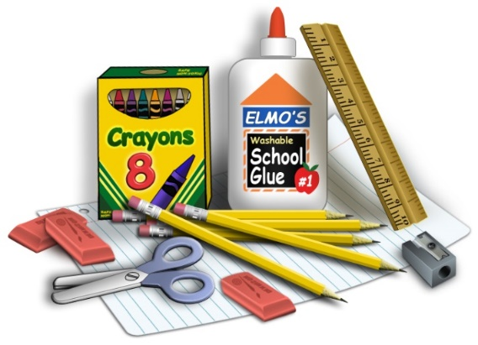

Note Section for ALL Students on back of this list
5 Year Olds

PLEASE LABEL:
Washable Crayola Crayons - 16 Pack
Washable Crayola Markers (Classic Colors)- 8 Pack
Washable Crayola Watercolors (Strip of 8)
Colored Pencils- 12 Pk
Elmer’s Washable Glue (2)-Small Bottle
Glue Sticks- 2
Fiskars Scissors
Acrylic Paint (all colors)
Old Adult T-shirt for Art
1” Binder
Non-Spill Juice Cup (for daily snack time)
Small Lunch Box/Bag (for daily snack time)
Pencil Box- Size 8 5/8” x 5 ¾” x 2 ½”
Kidnapper for naptime
(attachable pillow and blanket)
FOR FULL DAY STUDENTS ONLY
Change of Clothes in a Ziploc Bag
NO BACKPACKS-School will supply tote bag

PLEASE DON’T LABEL:
Ziploc Bags (Sandwich, Quart, or Gallon)
Playdoh-Variety 4 Pack
Germ-X
Clorox Wipes (2-3pk)
1-Lysol Disinfectant Spray
Expo Markers-Regular
Baby Wipes-Unscented-(2)
Paper Towels (4)
Kleenex (2)
Foaming Soap (2)
Off Family Care Insect Repellent (NO DEET)
Coppertone Kids Continuous Spray Sunscreen
(50 SPF)

4 Year Olds

PLEASE LABEL:
2-Washable Crayola Crayons - 16 Pack (NO JUMBO)
1-Washable Crayola Markers (Classic Colors)- 8 Pk
1-Washable Crayola Multicultural Colors Markers- 8 pk
2-Washable Crayola Watercolors (Strip of 8)
Colored Pencils- 12 Pk
Elmer’s Washable Glue (2)-Small Bottle
Glue Sticks- 4
Fiskars Scissors
Acrylic Paint (all colors)
Paint Smock/Old Adult T-shirt
Pencil Box- Size 8 5/8” x 5 ¾” x 2 ½”
Pencil pouch with binder rings
PLASTIC Folder w/2 pockets (for daily papers) or
½” Binder with clear pocket on front
Non-Spill Juice Cup (for daily snack time)
Small Lunch Box/Bag (for daily snack time)
Kidnapper for naptime
(attachable pillow and blanket)
FOR FULL DAY STUDENTS ONLY
Change of Clothes in a Ziploc Bag
NO BACKPACKS-School will supply tote bag

PLEASE DON’T LABEL:
Ziploc Bags (Sandwich, Quart, or Gallon)
Playdoh-Variety 4 Pack
Germ-X
Clorox Wipes (2-3pk)
Expo Markers-Fine Point & Chisel Tip
Baby Wipes-Unscented-(2)
Paper Towels (2)
Kleenex (2)
Foaming Soap (2)
Off Family Care Insect Repellent (NO DEET)
Coppertone Kids Continuous Spray Sunscreen
(50 SPF)

ALL STUDENTS
Optional Items: White Cardstock, Wooden Craft Sticks, Paper Plates, Googly Eyes, Tissue Paper, Beads, Buttons, Variety shaped Pasta Noodles, Cotton balls, Shaving Cream, Bubbles

** Donations of Age Appropriate Books or Gift Card for the Classroom would be much appreciated**

Each teacher may also have items on their “Wish Tree” that they would like for the classroom. Please consider assisting the teachers with those items. The lists will be available in your child’s classroom the night of Open House.
**THANK YOU**

